

CHEMISTRY

Semester One

Examination 2024

MARKING GUIDE

Section One: Multiple-choice 25% (25 marks)

1 | a □ b □ c □ d ■ |  | 6 | a □ b □ c □ d ■ |  | 11 | a □ b □ c ■ d □
2 | a □ b □ c □ d ■ |  | 7 | a □ b □ c □ d ■ |  | 12 | a □ b □ c ■ d □
3 | a □ b □ c ■ d □ |  | 8 | a □ b ■ c □ d □ |  | 13 | a □ b □ c ■ d □
4 | a □ b □ c ■ d □ |  | 9 | a □ b □ c ■ d □ |  | 14 | a □ b □ c ■ d □
5 | a □ b □ c □ d ■ |  | 10 | a □ b ■ c □ d □ |  | 15 | a ■ b □ c □ d □

16 | a ■ b □ c □ d □ |  | 21 | a □ b ■ c □ d □
17 | a □ b □ c □ d ■ |  | 22 | a □ b □ c □ d ■
18 | a ■ b □ c □ d □ |  | 23 | a □ b □ c □ d ■
19 | a □ b ■ c □ d □ |  | 24 | a □ b □ c ■ d □
20 | a □ b □ c ■ d □ |  | 25 | a ■ b □ c □ d □

Section Two: Short answer 35% (61 marks)

Question 26 (10 marks)

(a) Complete the table above. (8 marks)

Description | Marks
Species Symbol Protons Neutrons Electron config. Mass number  W $${}_{}^{\text{2}\text{2}}{\text{Na}}$$ 11 11 2, 8, 1 22  X ${}_{}^{\text{31}}{\text{P}}$³⁻ 15 16 2, 8, 8 31  Y ${}_{}^{\text{24}}{\text{Mg}}$²⁺ 12 12 2, 8 24  Z $${}_{}^{\text{36}}{\text{C}\text{l}}$$ 17 19 2, 8, 7 36  Award 1 mark per correct cell. | 8
Total | 8

(b) Which of these species is a cation? Describe how a cation is formed. (2 marks)

Description | Marks
Y / ²⁴Mg²⁺ | 1
Formed when a species loses electrons / has a greater number of protons than electrons. | 1
Total | 2

Question 27 (6 marks)

Complete the table below, by writing either the name or the formula of the compound.

Description | Marks
Name Formula  sodium dichromate Na₂Cr₂O₇  hydrogen peroxide H₂O₂  iron(III) chloride FeCl₃  zinc hydroxide Zn(OH)₂  boron trihydride BH₃  ammonium phosphide (NH₄)₃P  Award 1 mark per correct cell. | 6
Total | 6

Question 28 (12 marks)

(a) State the location of antimony on the periodic table. (2 marks)

Description | Marks
Period number 5 | 1
Group number 15 | 1
Total | 2

(b) Determine the identity of the other isotope of antimony. Support your answer with relevant calculations. (3 marks)

Description | Marks
(0.6 x 121) + (0.4 x $x$) = 121.8 | 1
72.6 + 0.4 $x$ = 121.8  0.4 $x$ = 49.2 | 1
$x$ = 123  Other isotope is Sb-123 | 1
Total | 3
Note: award full marks for other valid calculation methods; if logic is sound, no penalty if every step not shown

(c) Use your answer to part (b) to complete the mass spectrometer readout above. (1 mark)

Description | Marks
Correctly drawn column for Sb-123. | 1
Total | 1
Note: award follow through marks if incorrect calculation in part (b).

(d) Briefly outline how this calibration curve would have been obtained. (3 marks)

Description | Marks
Use samples with known Sb concentration. | 1
Analyse samples by AAS to determine absorbances. | 1
Plot data points with line of best fit. | 1
Total | 3

(e) Calculate the number of moles of antimony that a person would ingest, if 1 g of this drinking water was consumed. (Note: 1 ng = 1.0 x 10⁻⁹ g) (3 marks)

Description | Marks
In 1 g of water;  m(Sb) = 4 ng | 1
= 4 x 10⁻⁹ g | 1
n(Sb) = 4 x 10⁻⁹ / 121.8  = 3.284 x 10⁻¹¹ mol | 1
Total | 3

Question 29 (5 marks)

Consider the six (6) gas samples, labelled A – F, shown in the diagrams below. Different types of atoms are represented by different patterns and shading. Using these diagrams, answer the questions below.

Description | Marks
Which samples are pure substances? A, B, D  Which sample could be chlorine gas? D  Which sample is a mixture of elements? F  Which samples contain a compound? A, C, E  Suggest the identity of gas sample B. any Noble gas  Award 1 mark per correct cell. | 5
Total | 5

Question 30 (8 marks)

(a) Explain, in terms of structure and bonding, these bolded properties of platinum. (6 marks)

Description | Marks
Description of metallic bonding:  Metallic bonding consists of positive metal ions in a sea of delocalised electrons. | 1
High melting point:  - There is a strong electrostatic attraction (between the delocalised electrons and metal ions),  - Therefore a large amount of heat is required to disrupt the bonding. | 2
Ductile:  - The bonding (between the delocalised electrons and metal ions) is non-directional,  - Therefore when a force is applied the metal can change shape without disrupting bonds. | 2
Electrical conductivity:  Mobile charge is present in the form of delocalised electrons, (allowing platinum to conduct electricity). | 1
Total | 6

(b) Identify the type of bonding that accounts for the higher melting point of graphite. Give a brief description of this type of bonding. (2 marks)

Description | Marks
Covalent network | 1
Strong covalent bonding extends throughout large interconnected network. | 1
Total | 2

Question 31 (6 marks)

(a) Identify which substance is likely to match this description, and justify your answer in terms of the bonding present. (2 marks)

Description | Marks
H₂SiF₆ | 1
The covalent molecular bonding present results in a lower melting point / a liquid at room temperature. | 1
Total | 2

(b) Calculate the percentage composition of sodium fluorosilicate (Na₂SiF₆). (4 marks)

Description | Marks
M(Na₂SiF₆) = 188.07 g mol⁻¹ | 1
% Na = (2 x 22.99) / 188.07 x 100  = 24.45% | 1
% Si = 28.09 / 188.07 x 100  = 14.94% | 1
% F = (6 x 19) / 188.07 x 100  = 60.62% | 1
Total | 4

Question 32 (6 marks)

(a) Identify one (1) component of; (2 marks)

Description | Marks
(i) CaCO₃ / HCl | 1
(ii) beaker / benchtop / air / laboratory | 1
Total | 2

(b) Classify this reaction as endothermic or exothermic. (1 mark)

Description | Marks
Endothermic | 1
Total | 1

(c) Identify whether the beaker would have felt cooler or warmer when the reaction was taking place, compared to before the acid was added. (1 mark)

Description | Marks
Cooler | 1
Total | 1

(d) Compare the energy associated with the bond breaking and bond making processes involved in this reaction. (2 marks)

Description | Marks
The energy required to break the bonds is less | 1
than the energy released when new bonds form | 1
Total | 2

Question 33 (8 marks)

(a) Calculate the number of moles of phosphoric acid produced. (2 marks)

Description | Marks
m(H₃PO₄) = 1.83 x 10³  = 1830 g | 1
n(H₃PO₄) = 1830 / 97.994  = 18.6746 mol | 1
Total | 2

(b) Calculate the percentage purity of the fluorapatite used. The molar mass of fluorapatite is 504.31 g mol⁻¹. (4 marks)

Description | Marks
n(Ca₅(PO₄)₃F) = (1/3) x n(H₃PO₄)  = (1/3) x 18.6746  = 6.2249 mol | 1
m(Ca₅(PO₄)₃F) = 6.2249 x 504.31  = 3139.3 g | 1
= 3.1393 kg | 1
% purity = 3.1393 / 3.24 x 100  = 96.9% | 1
Total | 4

(c) Calculate the mass of calcium sulfate that would have been produced. (2 marks)

Description | Marks
n(CaSO₄) = (5/3) x n(H₃PO₄)  = (5/3) x 18.6746  = 31.1244 mol | 1
m(CaSO₄) = 31.1244 x 136.14  = 4237 g OR 4.24 kg | 1
Total | 2

Section Three: Extended answer 40% (65 marks)

Question 34 (17 marks)

(a) On the graph above, label each line to indicate which represents the period 2 elements and which represents the period 3 elements. (1 mark)

Description | Marks
Dotted line (- - -) labelled as Period 2  Solid line (–––) labelled as Period 3 | 1
Total | 1

(b) Justify the choice you made in part (a). Your answer should include a definition of first ionisation energy. (4 marks)

Description | Marks
First ionisation energy is the energy required to remove one mole of electrons from one mole of atoms in the gaseous state. | 1
Period 2 elements have their valence electrons in the second shell / in a shell closer to the nucleus than period 3 elements.  or  Period 3 elements have their valence electrons in the third shell / in a shell further from the nucleus than period 2 elements, | 1
Therefore the valence electrons (in the period 2 elements) experience a greater attractive force from the positive nucleus.  or  Therefore the valence electrons (in the period 3 elements) experience a lesser attractive force from the positive nucleus. | 1
Thus (the valence electrons in the period 2 elements) require more energy to remove.  or  Thus (the valence electrons in the period 3 elements) require less energy to remove. | 1
Total | 4

(c) Explain why the general trend in first ionisation energy shows an increase across a period. (3 marks)

Description | Marks
There is an increased number of positive protons in the nucleus as you move across a period. | 1
Thus the electrons are held more strongly / experience greater attraction to the nucleus. | 1
Therefore the electrons are harder to remove / more energy is required to remove the electrons. | 1
Total | 3

(d) Explain why the group 18 elements in period 2 and 3 are not assigned an electronegativity value. Your answer should include a definition of electronegativity. (3 marks)

Description | Marks
Electronegativity is the force of attraction exerted on a bonding pair of electrons.  The ability of an atom in a molecule to attract shared electrons. | 1
Group 18 elements have a stable electron arrangement, with 8 electrons in the valence shell (or 2 in the case of He). | 1
Thus they do not tend to attract electrons. | 1
Total | 3

(e) Identify which has the; (2 marks)
- smallest atomic radius.
- largest atomic radius.

Description | Marks
(i) Neon / Ne | 1
(ii) Sodium / Na | 1
Total | 2

(f) Identify two elements that could have produced compound XY₂ if the bonding within the compound was; (2 marks)
- ionic.
- covalent.

Description | Marks
(i) magnesium and chlorine / MgCl₂ | 1
(ii) sulfur and chlorine / SCl₂ | 1
Total | 2

(g) Describe the difference between ionic and covalent bonding, in terms of electron behaviour. (2 marks)

Description | Marks
In ionic bonding electrons are transferred. | 1
In covalent bonding electrons are shared. | 1
Total | 2

Question 35 (17 marks)

(a) Describe how UV radiation can result in diatomic carbon becoming ‘excited’. (2 marks)

Description | Marks
Electrons can absorb energy/photons from the UV radiation, | 1
causing electrons to move to higher energy levels / to electrons shells further from the nucleus (resulting in the atom becoming excited). | 1
Total | 2

(b) Describe how the excited diatomic carbon is then able to produce this distinctive green light. (3 marks)

Description | Marks
The atoms return to the ground state / The electrons fall back to lower energy levels, | 1
releasing energy/photons (equivalent to the difference in energy between the electrons shells) as they do so. | 1
The wavelength/frequency of the light/photons emitted corresponds to a green colour. | 1
Total | 3

(c) Describe how diamond and graphite are structurally different from one another. Use diagrams to support your answer. (6 marks)

Description | Marks
In diamond, every carbon atom is bonded to 4 other carbon atoms. | 1
This results in a 3D network (containing no delocalised electrons). | 1
In graphite, every carbon atom is bonded to 3 other carbon atoms. | 1
This results in layers of carbon/graphene interspersed with layers of delocalised electrons. | 1
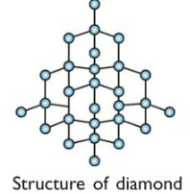 | 1
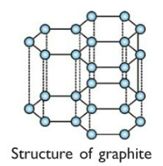 | 1
Total | 6

(d) Define an isotope. (1 mark)

Description | Marks
Atoms with the same number of protons, but a different number of neutrons.  or  Atoms with the same atomic number, but a different mass number.  or  Atoms of the same element that have different numbers of neutrons. | 1
Total | 1

(e) State whether this molecule, when excited, would be likely to emit the same green light observed from comet C/2022 E3. Justify your answer. (2 marks)

Description | Marks
Yes, same colour likely. | 1
Isotopes have the same number of electrons / same electron configuration.  or  Isotopes have the same chemical properties. | 1
Total | 2

(f) Calculate the mass of carbon-13 atoms likely to be present in this sample. (3 marks)

Description | Marks
%(C-13) = 100 – 98.93  = 1.07 % | 1
m(C-13) = (1.07/100) x 0.0344  = 3.6808 x 10⁻⁴ g | 1  1
Total | 3

Question 36 (15 marks)

(a) Write a balanced thermochemical equation for the combustion of benzene in excess oxygen. (3 marks)

Description | Marks
2 C₆H₆(g) + 15 O₂(g) → 12 CO₂(g) + 6 H₂O(g) + 6530 kJ
or
2 C₆H₆(g) + 15 O₂(g) → 12 CO₂(g) + 6 H₂O(g) ΔH = -3265 kJ mol⁻¹
Correct species | 1
Correct balancing | 1
Correct enthalpy change | 1
Total | 3

- Sketch an energy profile diagram for the combustion of benzene.
(Include the terms: enthalpy (H), progress of reaction, reactants, products, Ea and ΔH).
(5 marks)
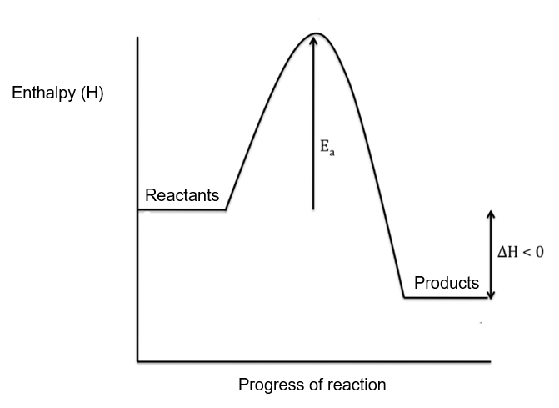
Description | Marks
Axis correctly labelled: x-axis progress of reaction  y-axis enthalpy (H) | 1
Reactants and Products labelled | 1
Correct shape (exothermic) | 1
E_{a} | 1
ΔH | 1
Total | 5

(c) Justify how the data collected by the students supports this statement. (2 marks)

Description | Marks
Exothermic reactions release heat | 1
This is shown by the temperature increase of the water. | 1
Total | 2

(d) Calculate the number of moles of benzene that reacted. (2 marks)

Description | Marks
m(C₆H₆ combusted) = 149.33 – 148.21  = 1.12 g | 1
n(C₆H₆) = 1.12 / 78.108  = 0.01434 mol | 1
Total | 2

(e) Calculate the experimentally determined molar heat of combustion of benzene (kJ mol⁻¹). (1 mark)

Description | Marks
ΔH_{c} = 43.24 / 0.01434  = 3015.5 kJ mol⁻¹ | 1
Total | 1

(f) State whether this suggests the presence of random or systematic error. (1 mark)

Description | Marks
Systematic | 1
Total | 1

(g) Identify one (1) potential sources of this type of error. (1 marks)

Description | Marks
Any one (1) acceptable answer, including;  - Heat of Bunsen burner flame lost to surroundings  - Heat lost from water to surroundings / no insulation on beaker  - Incorrect calibration of thermometer  - Incorrect calibration of balance  - Balance not zeroed/tared | 1
Total | 1

Question 37 (16 marks)

(a) Identify the type of bonding exhibited by these substances. (2 marks)

Description |  | Marks
Sodium chloride | ionic | 1
Water | covalent (molecular) | 1
Total |  | 2

(b) Explain, in terms of structure and bonding, why there is such a difference in the melting point of sodium chloride and water. (6 marks)

Description | Marks
NaCl is an ionic substance | 1
In NaCl there are strong electrostatic attractions between the cations and anions. | 1
Therefore a large amount of heat is required to disrupt the bonding. | 1
H₂O is a covalent molecular substance | 1
In H₂O there are discrete molecules with weak intermolecular forces. | 1
Therefore a small amount of heat is required to disrupt the bonding. | 1
Total | 6

(c) Explain, in terms of structure and bonding, why solid sodium chloride and liquid water are each unable to conduct electricity, but when mixed together the resulting sodium chloride solution can conduct electricity. (5 marks)

Description | Marks
Neither NaCl(s) or H₂O(l) contain mobile charge. | 1
In NaCl(s) the ions are held in fixed positions | 1
In H₂O(l) all electrons are localised. | 1
In NaCl(aq) the ions have dissociated.  or  NaCl(aq) → Na⁺(aq) + Cl⁻(aq) | 1
This produces mobile charge/ions (which are able to conduct electricity). | 1
Total | 5

(e) Identify the name of this separation technique. (1 mark)

Description | Marks
Distillation | 1
Total | 1

(f) Label on the diagram above, where the solid sodium chloride and liquid water would each be found, upon completion of the separation process. (2 marks)

Description | Marks
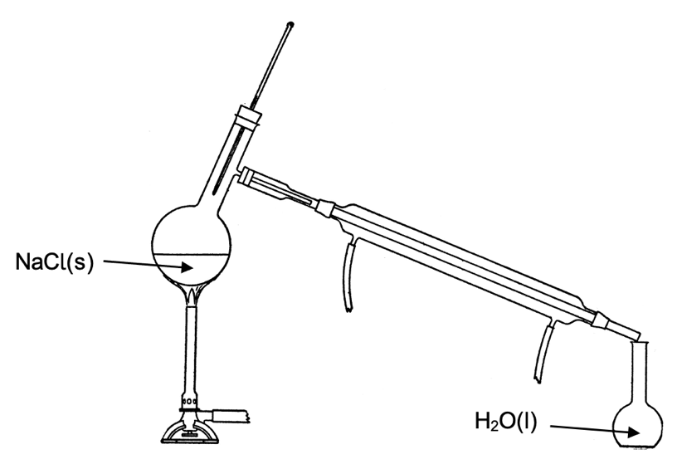

Correctly identifies NaCl(s) location | 1
Correctly identifies H₂O(l) location | 1
Total | 2

